TMT/ Bengaluru /S0452/2025 08-09-2025

To,

Venkatesh
Bengaluru, KA
call: +91-8861477349

Dear Sir,

Sub :- Supply of Three Roller Plate Bending machine

We thank you for your inquiry regarding Plate Bending machine for MS plate width 1500 and thickness 6 mm. We are glad to inform you that we would be in a position to do the required equipment. Given below are the specifications and description of the machine and our terms and conditions.

S No | Description of the unit | Offer
1. | Supply of Three Roller Plate Bending machine for 1500 X 6MM along electrical. | Rs 3,80,000/- (Rupees Three Lakh Eighty Thousand Only)

Specifications of the equipment

1) Maximum width of the plate that can be rolled : 1500 MM

2) Maximum thickness of the plate that can be rolled : 6 MM

3) Top Roll diameter : 125 MM

4) Bottom Roller Diameter : 115 MM

5) Minimum Rolling Diameter : 270 MM

6) Rolling speed : 3.0 Meters/Min.

7) Maximum yield limit of the plate : 245 Mpa.

8) Total power : 5 HP
GENERAL TERMS & CONDITIONS:

- Price quoted per unit ex-work. Hyderabad.
- Following charges are additional to your account.
- Freight Charge : As actual to be borne by you.
- Sales Tax : 18% Extra as applicable
- Packing charge : As actual to be borne by you.
- Insurance : As actual to be borne by you.
- Payment : 50% advance along with order balance before delivery but after inspection at our works.
- Delivery : With 40% advance 1 months from date of advance received
- Validity : One month from the date of submission.
- Inspection : Inspection at our works prior to dispatch.
- Warranty : The machine is warranted for a period of 12 months from the date of dispatch against any manufacturing defects/ faulty material or bad workmanship of any part or component but not against any kind of abnormal or improper use of machine. Defective part or component will be replaced or repaired free of cost. Electrical components are outside the scope of this warranty.
- Commissioning : Erection & commissioning done by you, but required technical support & guidance provide by us at additional cost.

NOTE:
- Oil is not in scope of our supply.
- Raw material for trial is to be arranged by you at your cost.

We are sure you will find our offer in line with your requirements. Should you require any further clarification please contact T. SIVARAMAKRISHNA 9246221106/9849207176

Thanking you and assuring you of our best services.

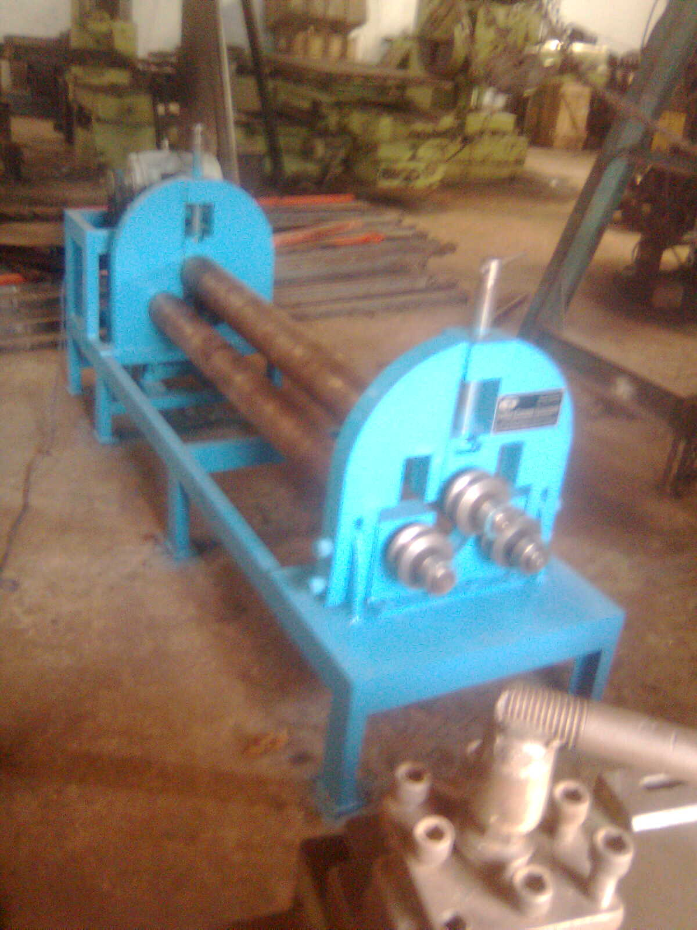

For TECHNO MACHINE TOOLS

( T. SIVARAMAKRISHNA)

TMT/ Bengaluru /S0452/2025 08-09-2025

To,

Venkatesh
Bengaluru, KA
call: +91-8861477349

Dear sir,

Sub :- Supply of HYDRAULIC PRESS BRAKE MACHINE.

Thank you very much for your enquiry regarding your requirement of hydraulic press brake. We are glad to inform you that we would be in a position to supply you the required equipment. Given below are the required specifications and description of the machine and our terms and conditions.

PRESS BRAKE :

1) Size : 1500 X 6 M.M.

2) Tonnage : 20 M.T.

S No | Description of the unit | Offer
1. | Hydraulic Press Brake with bending capacity 1.5 Meters and 6 mm MS Sheet, 20 MT load capacity with Power pack of 3 HP motor along with one set Standard Die and Punch. | Rs 3,60,000/-  (Rupees Three Lakhs  Sixty Thousand Only)

SPECIFICATIONS FOR THE HYDRAULIC PRESS BRAKE MACHINE WITH 1500 M.M. WIDTH AND 6 M.M. THICKNES.

1. Tonnage : 20 M.T.

2. Clearance between Housings : 750 M.M.

3. Bending capacity in M.S. : 1500 x 6 M.M.

4. Ram stroke. : 150 M.M.

5. Open height. : 350 M.M.

6. Closed height. : 200 M.M.

7. Depth of Throat. : 300 M.M.

- Ram speeds.

a) Approach. : 22 M.M. per Sec.

b) Pressing. : 3 M.M. per Sec.

c) Return. : 40 M.M. per Sec.

9. Motor capacity. : 5 H.P. (Crompton)

10. Punch. : 1500 x 155 x 18 M.M.

11. Bed size. : 1500 x 125 x 50 M.M.

12. Cost of Machine. : Rs. 3,60,000/- + Taxes.

13. Mode of payment. : As per the quotation.

14. Delivery. : As per the quotation.

GENERAL TERMS & CONDITIONS:

- Price quoted per unit ex-work. Hyderabad.
- Following charges are additional to your account.
- Freight Charge : As actual to be borne by you.
- Sales Tax : 18% Extra.
- Packing charge : As actual to be borne by you.
- Insurance : As actual to be borne by you.
- Payment : 50% advance along with order balance before delivery but after inspection at our works.
- Delivery : with in 1 months
- Validity : One month from the date of submission.
- Inspection : Inspection at our works prior to dispatch.
- Warranty : The machine is warranted for a period of 12 months from the date of dispatch against any manufacturing defects/ faulty material or bad workmanship of any part or component but not against any kind of abnormal or improper use of machine. Defective part or component will be replaced or repaired free of cost. Electrical components are outside the scope of this warranty.
- Commissioning : Erection & commissioning done by you, but required technical support & guidance provide by us at additional cost.
NOTE:
- Oil is not in scope of our supply.
- Raw material for trial is to be arranged by you at your cost.

We are sure you will find our offer in line with your requirements. Should you require any further clarification please contact 9246221106
Thanking you and assuring you of our best services

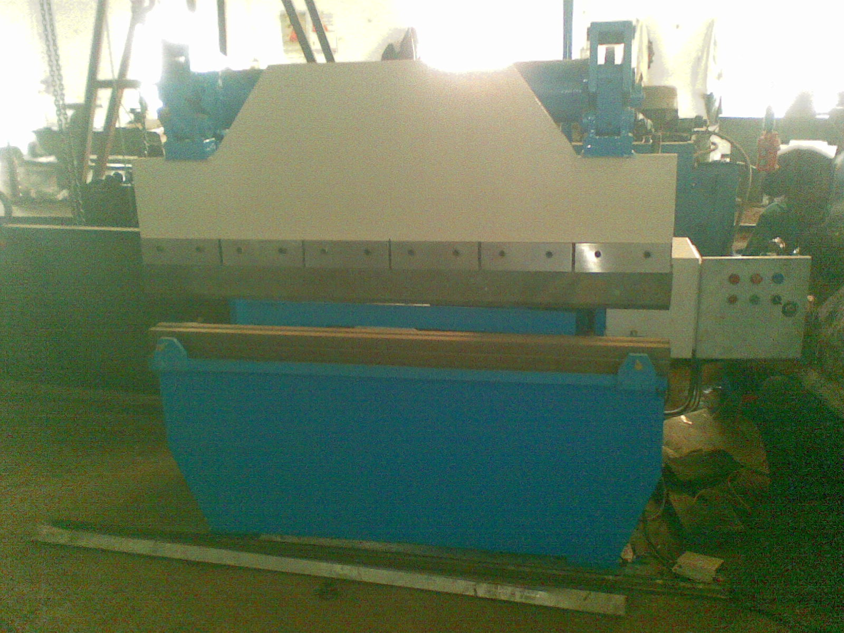
For TECHNO MACHINE TOOLS

T. SIVARAMAKRISHNA

